# Feature Catalogue Arctic SDI

**Version:**

0.2.1

**Date:**

2023-09-04T13:35:23.2449183+02:00

**Scope:**

This feature catalogue describes features from the Arctic SDI Topographic Basemap. This feature catalogue conforms to DS/EN ISO 19110.

**Responsible organisation:**

SDFI

## Application schema: ArcticSDI

**Version:**

0.2.1

**Sub-package:**

Boundaries

Elevation

GeographicalNames

Hydrography

LandCover

TransportNetworks

**Diagram(s):**

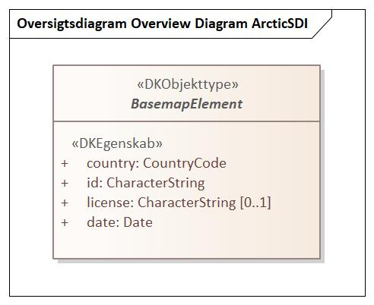

Figure - Overview Diagram ArcticSDI

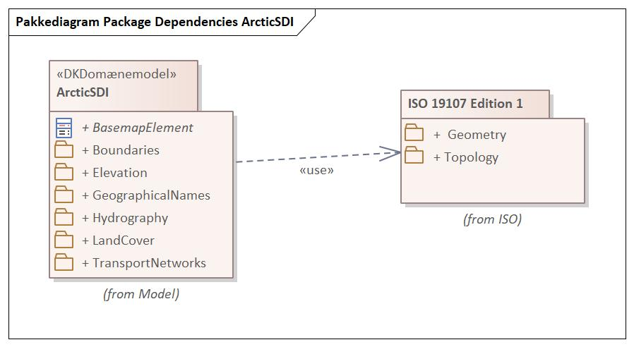

Figure - Package Dependencies ArcticSDI

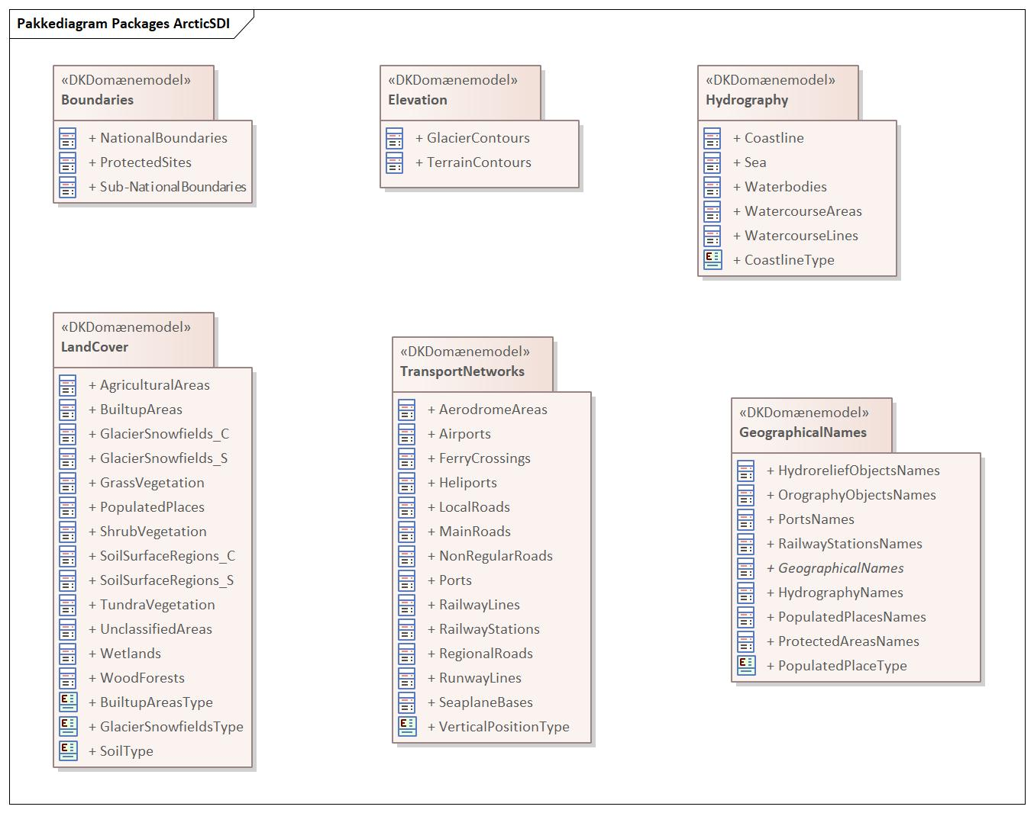

Figure - Packages ArcticSDI

### BasemapElement

|  |  |  |  |  |  |  |
| --- | --- | --- | --- | --- | --- | --- |
| **BasemapElement**   |  |  | | --- | --- | | **Supertype of:** | AerodromeAreas  AgriculturalAreas  Airports  BuiltupAreas  Coastline  FerryCrossings  GeographicalNames  GlacierContours  GlacierSnowfields_C  GlacierSnowfields_S  GrassVegetation  Heliports  LocalRoads  MainRoads  NationalBoundaries  NonRegularRoads  PopulatedPlaces  Ports  ProtectedSites  RailwayLines  RailwayStations  RegionalRoads  RunwayLines  Sea  SeaplaneBases  ShrubVegetation  SoilSurfaceRegions_C  SoilSurfaceRegions_S  Sub-NationalBoundaries  TerrainContours  TundraVegetation  UnclassifiedAreas  Waterbodies  WatercourseAreas  WatercourseLines  Wetlands  WoodForests | | **Type:** | Feature type | | **Abstract:** | true | |
| **Attribute:**   |  |  | | --- | --- | | **Name:** | country | | **Definition:** | three-letter country code defined in ISO 3166-1 | | **Multiplicity:** | 1 | | **Value type:** | CountryCode (code list) | |
| **Attribute:**   |  |  | | --- | --- | | **Name:** | id | | **Definition:** | identifikation of the feature which in combination with the country code is unique | | **Multiplicity:** | 1 | | **Value type:** | CharacterString | |
| **Attribute:**   |  |  | | --- | --- | | **Name:** | license | | **Definition:** | description or reference to any commercial (or similar) license or copyright notice applicable to information regarding the feature or data set | | **Multiplicity:** | 0..1 | | **Value type:** | CharacterString | |
| **Attribute:**   |  |  | | --- | --- | | **Name:** | date | | **Definition:** | date supplied in the data delivery | | **Description:** | The date may come from the source data or it may be set when extracting and transferring data, i.e. the organization supplying the data decides how the atribute is populated. | | **Multiplicity:** | 1 | | **Value type:** | Date | |

## Package: GeographicalNames

**Parent package:**

ArcticSDI

**Diagram(s):**

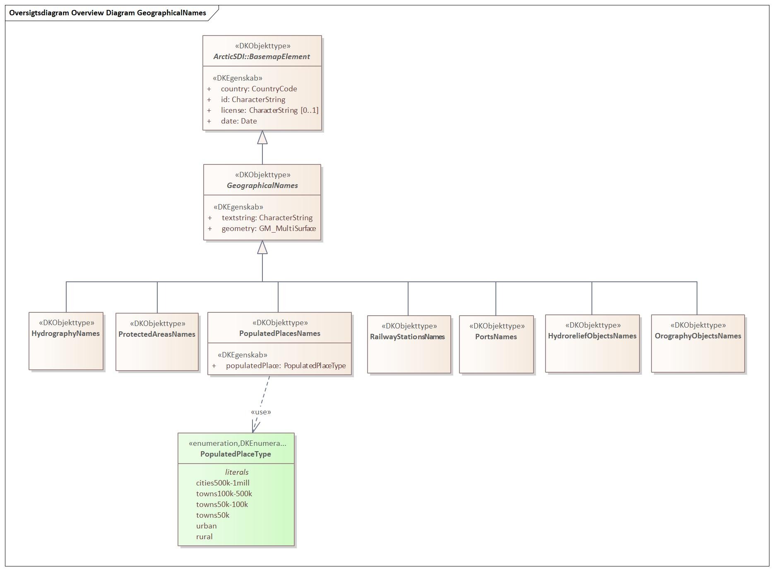

Figure - Overview Diagram GeographicalNames

### GeographicalNames

|  |  |  |  |  |  |  |  |  |
| --- | --- | --- | --- | --- | --- | --- | --- | --- |
| **GeographicalNames**   |  |  | | --- | --- | | **Subtype of:** | BasemapElement | | **Supertype of:** | HydrographyNames  HydroreliefObjectsNames  OrographyObjectsNames  PopulatedPlacesNames  PortsNames  ProtectedAreasNames  RailwayStationsNames | | **Type:** | Feature type | | **Abstract:** | true | |
| **Attribute:**   |  |  | | --- | --- | | **Name:** | country | | **Definition:** | three-letter country code defined in ISO 3166-1 | | **Multiplicity:** | 1 | | **Value type:** | CountryCode (code list) | |
| **Attribute:**   |  |  | | --- | --- | | **Name:** | id | | **Definition:** | identifikation of the feature which in combination with the country code is unique | | **Multiplicity:** | 1 | | **Value type:** | CharacterString | |
| **Attribute:**   |  |  | | --- | --- | | **Name:** | license | | **Definition:** | description or reference to any commercial (or similar) license or copyright notice applicable to information regarding the feature or data set | | **Multiplicity:** | 0..1 | | **Value type:** | CharacterString | |
| **Attribute:**   |  |  | | --- | --- | | **Name:** | date | | **Definition:** | date supplied in the data delivery | | **Description:** | The date may come from the source data or it may be set when extracting and transferring data, i.e. the organization supplying the data decides how the atribute is populated. | | **Multiplicity:** | 1 | | **Value type:** | Date | |
| **Attribute:**   |  |  | | --- | --- | | **Name:** | textstring | | **Multiplicity:** | 1 | | **Value type:** | CharacterString | |
| **Attribute:**   |  |  | | --- | --- | | **Name:** | geometry | | **Multiplicity:** | 1 | | **Value type:** | GM_MultiSurface | |

### HydrographyNames

|  |  |  |  |  |  |  |
| --- | --- | --- | --- | --- | --- | --- |
| **HydrographyNames**   |  |  | | --- | --- | | **Definition:** | Oceans, seas, bays, lakes, reservoirs, rivers, canals | | **Subtype of:** | GeographicalNames | | **Type:** | Feature type | |
| **Attribute:**   |  |  | | --- | --- | | **Name:** | country | | **Definition:** | three-letter country code defined in ISO 3166-1 | | **Multiplicity:** | 1 | | **Value type:** | CountryCode (code list) | |
| **Attribute:**   |  |  | | --- | --- | | **Name:** | id | | **Definition:** | identifikation of the feature which in combination with the country code is unique | | **Multiplicity:** | 1 | | **Value type:** | CharacterString | |
| **Attribute:**   |  |  | | --- | --- | | **Name:** | license | | **Definition:** | description or reference to any commercial (or similar) license or copyright notice applicable to information regarding the feature or data set | | **Multiplicity:** | 0..1 | | **Value type:** | CharacterString | |
| **Attribute:**   |  |  | | --- | --- | | **Name:** | date | | **Definition:** | date supplied in the data delivery | | **Description:** | The date may come from the source data or it may be set when extracting and transferring data, i.e. the organization supplying the data decides how the atribute is populated. | | **Multiplicity:** | 1 | | **Value type:** | Date | |
| **Attribute:**   |  |  | | --- | --- | | **Name:** | textstring | | **Multiplicity:** | 1 | | **Value type:** | CharacterString | |
| **Attribute:**   |  |  | | --- | --- | | **Name:** | geometry | | **Multiplicity:** | 1 | | **Value type:** | GM_MultiSurface | |

### HydroreliefObjectsNames

|  |  |  |  |  |  |  |
| --- | --- | --- | --- | --- | --- | --- |
| **HydroreliefObjectsNames**   |  |  | | --- | --- | | **Definition:** | Islands, peninsulas, capes | | **Subtype of:** | GeographicalNames | | **Type:** | Feature type | |
| **Attribute:**   |  |  | | --- | --- | | **Name:** | country | | **Definition:** | three-letter country code defined in ISO 3166-1 | | **Multiplicity:** | 1 | | **Value type:** | CountryCode (code list) | |
| **Attribute:**   |  |  | | --- | --- | | **Name:** | id | | **Definition:** | identifikation of the feature which in combination with the country code is unique | | **Multiplicity:** | 1 | | **Value type:** | CharacterString | |
| **Attribute:**   |  |  | | --- | --- | | **Name:** | license | | **Definition:** | description or reference to any commercial (or similar) license or copyright notice applicable to information regarding the feature or data set | | **Multiplicity:** | 0..1 | | **Value type:** | CharacterString | |
| **Attribute:**   |  |  | | --- | --- | | **Name:** | date | | **Definition:** | date supplied in the data delivery | | **Description:** | The date may come from the source data or it may be set when extracting and transferring data, i.e. the organization supplying the data decides how the atribute is populated. | | **Multiplicity:** | 1 | | **Value type:** | Date | |
| **Attribute:**   |  |  | | --- | --- | | **Name:** | textstring | | **Multiplicity:** | 1 | | **Value type:** | CharacterString | |
| **Attribute:**   |  |  | | --- | --- | | **Name:** | geometry | | **Multiplicity:** | 1 | | **Value type:** | GM_MultiSurface | |

### OrographyObjectsNames

|  |  |  |  |  |  |  |
| --- | --- | --- | --- | --- | --- | --- |
| **OrographyObjectsNames**   |  |  | | --- | --- | | **Definition:** | High mountains, mountain ridges, highlands | | **Subtype of:** | GeographicalNames | | **Type:** | Feature type | |
| **Attribute:**   |  |  | | --- | --- | | **Name:** | country | | **Definition:** | three-letter country code defined in ISO 3166-1 | | **Multiplicity:** | 1 | | **Value type:** | CountryCode (code list) | |
| **Attribute:**   |  |  | | --- | --- | | **Name:** | id | | **Definition:** | identifikation of the feature which in combination with the country code is unique | | **Multiplicity:** | 1 | | **Value type:** | CharacterString | |
| **Attribute:**   |  |  | | --- | --- | | **Name:** | license | | **Definition:** | description or reference to any commercial (or similar) license or copyright notice applicable to information regarding the feature or data set | | **Multiplicity:** | 0..1 | | **Value type:** | CharacterString | |
| **Attribute:**   |  |  | | --- | --- | | **Name:** | date | | **Definition:** | date supplied in the data delivery | | **Description:** | The date may come from the source data or it may be set when extracting and transferring data, i.e. the organization supplying the data decides how the atribute is populated. | | **Multiplicity:** | 1 | | **Value type:** | Date | |
| **Attribute:**   |  |  | | --- | --- | | **Name:** | textstring | | **Multiplicity:** | 1 | | **Value type:** | CharacterString | |
| **Attribute:**   |  |  | | --- | --- | | **Name:** | geometry | | **Multiplicity:** | 1 | | **Value type:** | GM_MultiSurface | |

### PopulatedPlacesNames

|  |  |  |  |  |
| --- | --- | --- | --- | --- |
| **PopulatedPlacesNames**   |  |  | | --- | --- | | **Subtype of:** | GeographicalNames | | **Type:** | Feature type | |
| **Attribute:**   |  |  | | --- | --- | | **Name:** | country | | **Definition:** | three-letter country code defined in ISO 3166-1 | | **Multiplicity:** | 1 | | **Value type:** | CountryCode (code list) | |
| **Attribute:**   |  |  | | --- | --- | | **Name:** | id | | **Definition:** | identifikation of the feature which in combination with the country code is unique | | **Multiplicity:** | 1 | | **Value type:** | CharacterString | |
| **Attribute:**   |  |  | | --- | --- | | **Name:** | license | | **Definition:** | description or reference to any commercial (or similar) license or copyright notice applicable to information regarding the feature or data set | | **Multiplicity:** | 0..1 | | **Value type:** | CharacterString | |
| **Attribute:**   |  |  | | --- | --- | | **Name:** | date | | **Definition:** | date supplied in the data delivery | | **Description:** | The date may come from the source data or it may be set when extracting and transferring data, i.e. the organization supplying the data decides how the atribute is populated. | | **Multiplicity:** | 1 | | **Value type:** | Date | |
| **Attribute:**   |  |  | | --- | --- | | **Name:** | textstring | | **Multiplicity:** | 1 | | **Value type:** | CharacterString | |
| **Attribute:**   |  |  | | --- | --- | | **Name:** | geometry | | **Multiplicity:** | 1 | | **Value type:** | GM_MultiSurface | |
| **Attribute:**   |  |  | | --- | --- | | **Name:** | populatedPlace | | **Multiplicity:** | 1 | | **Value type:** | PopulatedPlaceType (enumeration) | | **Values** | |  |  | | --- | --- | | cities500k-1mill |  | | towns100k-500k |  | | towns50k-100k |  | | towns50k |  | | urban |  | | rural |  | | |

### PortsNames

|  |  |  |  |  |
| --- | --- | --- | --- | --- |
| **PortsNames**   |  |  | | --- | --- | | **Subtype of:** | GeographicalNames | | **Type:** | Feature type | |
| **Attribute:**   |  |  | | --- | --- | | **Name:** | country | | **Definition:** | three-letter country code defined in ISO 3166-1 | | **Multiplicity:** | 1 | | **Value type:** | CountryCode (code list) | |
| **Attribute:**   |  |  | | --- | --- | | **Name:** | id | | **Definition:** | identifikation of the feature which in combination with the country code is unique | | **Multiplicity:** | 1 | | **Value type:** | CharacterString | |
| **Attribute:**   |  |  | | --- | --- | | **Name:** | license | | **Definition:** | description or reference to any commercial (or similar) license or copyright notice applicable to information regarding the feature or data set | | **Multiplicity:** | 0..1 | | **Value type:** | CharacterString | |
| **Attribute:**   |  |  | | --- | --- | | **Name:** | date | | **Definition:** | date supplied in the data delivery | | **Description:** | The date may come from the source data or it may be set when extracting and transferring data, i.e. the organization supplying the data decides how the atribute is populated. | | **Multiplicity:** | 1 | | **Value type:** | Date | |
| **Attribute:**   |  |  | | --- | --- | | **Name:** | textstring | | **Multiplicity:** | 1 | | **Value type:** | CharacterString | |
| **Attribute:**   |  |  | | --- | --- | | **Name:** | geometry | | **Multiplicity:** | 1 | | **Value type:** | GM_MultiSurface | |

### ProtectedAreasNames

|  |  |  |  |  |
| --- | --- | --- | --- | --- |
| **ProtectedAreasNames**   |  |  | | --- | --- | | **Subtype of:** | GeographicalNames | | **Type:** | Feature type | |
| **Attribute:**   |  |  | | --- | --- | | **Name:** | country | | **Definition:** | three-letter country code defined in ISO 3166-1 | | **Multiplicity:** | 1 | | **Value type:** | CountryCode (code list) | |
| **Attribute:**   |  |  | | --- | --- | | **Name:** | id | | **Definition:** | identifikation of the feature which in combination with the country code is unique | | **Multiplicity:** | 1 | | **Value type:** | CharacterString | |
| **Attribute:**   |  |  | | --- | --- | | **Name:** | license | | **Definition:** | description or reference to any commercial (or similar) license or copyright notice applicable to information regarding the feature or data set | | **Multiplicity:** | 0..1 | | **Value type:** | CharacterString | |
| **Attribute:**   |  |  | | --- | --- | | **Name:** | date | | **Definition:** | date supplied in the data delivery | | **Description:** | The date may come from the source data or it may be set when extracting and transferring data, i.e. the organization supplying the data decides how the atribute is populated. | | **Multiplicity:** | 1 | | **Value type:** | Date | |
| **Attribute:**   |  |  | | --- | --- | | **Name:** | textstring | | **Multiplicity:** | 1 | | **Value type:** | CharacterString | |
| **Attribute:**   |  |  | | --- | --- | | **Name:** | geometry | | **Multiplicity:** | 1 | | **Value type:** | GM_MultiSurface | |

### RailwayStationsNames

|  |  |  |  |  |
| --- | --- | --- | --- | --- |
| **RailwayStationsNames**   |  |  | | --- | --- | | **Subtype of:** | GeographicalNames | | **Type:** | Feature type | |
| **Attribute:**   |  |  | | --- | --- | | **Name:** | country | | **Definition:** | three-letter country code defined in ISO 3166-1 | | **Multiplicity:** | 1 | | **Value type:** | CountryCode (code list) | |
| **Attribute:**   |  |  | | --- | --- | | **Name:** | id | | **Definition:** | identifikation of the feature which in combination with the country code is unique | | **Multiplicity:** | 1 | | **Value type:** | CharacterString | |
| **Attribute:**   |  |  | | --- | --- | | **Name:** | license | | **Definition:** | description or reference to any commercial (or similar) license or copyright notice applicable to information regarding the feature or data set | | **Multiplicity:** | 0..1 | | **Value type:** | CharacterString | |
| **Attribute:**   |  |  | | --- | --- | | **Name:** | date | | **Definition:** | date supplied in the data delivery | | **Description:** | The date may come from the source data or it may be set when extracting and transferring data, i.e. the organization supplying the data decides how the atribute is populated. | | **Multiplicity:** | 1 | | **Value type:** | Date | |
| **Attribute:**   |  |  | | --- | --- | | **Name:** | textstring | | **Multiplicity:** | 1 | | **Value type:** | CharacterString | |
| **Attribute:**   |  |  | | --- | --- | | **Name:** | geometry | | **Multiplicity:** | 1 | | **Value type:** | GM_MultiSurface | |

## Package: Boundaries

**Parent package:**

ArcticSDI

**Diagram(s):**

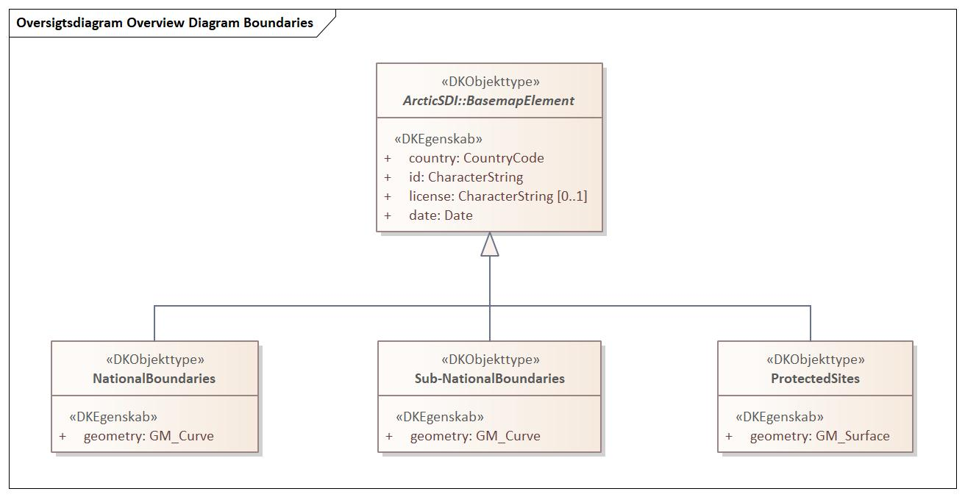

Figure - Overview Diagram Boundaries

### NationalBoundaries

|  |  |  |  |  |
| --- | --- | --- | --- | --- |
| **NationalBoundaries**   |  |  | | --- | --- | | **Subtype of:** | BasemapElement | | **Type:** | Feature type | |
| **Attribute:**   |  |  | | --- | --- | | **Name:** | country | | **Definition:** | three-letter country code defined in ISO 3166-1 | | **Multiplicity:** | 1 | | **Value type:** | CountryCode (code list) | |
| **Attribute:**   |  |  | | --- | --- | | **Name:** | id | | **Definition:** | identifikation of the feature which in combination with the country code is unique | | **Multiplicity:** | 1 | | **Value type:** | CharacterString | |
| **Attribute:**   |  |  | | --- | --- | | **Name:** | license | | **Definition:** | description or reference to any commercial (or similar) license or copyright notice applicable to information regarding the feature or data set | | **Multiplicity:** | 0..1 | | **Value type:** | CharacterString | |
| **Attribute:**   |  |  | | --- | --- | | **Name:** | date | | **Definition:** | date supplied in the data delivery | | **Description:** | The date may come from the source data or it may be set when extracting and transferring data, i.e. the organization supplying the data decides how the atribute is populated. | | **Multiplicity:** | 1 | | **Value type:** | Date | |
| **Attribute:**   |  |  | | --- | --- | | **Name:** | geometry | | **Multiplicity:** | 1 | | **Value type:** | GM_Curve | |

### ProtectedSites

|  |  |  |  |  |
| --- | --- | --- | --- | --- |
| **ProtectedSites**   |  |  | | --- | --- | | **Subtype of:** | BasemapElement | | **Type:** | Feature type | |
| **Attribute:**   |  |  | | --- | --- | | **Name:** | country | | **Definition:** | three-letter country code defined in ISO 3166-1 | | **Multiplicity:** | 1 | | **Value type:** | CountryCode (code list) | |
| **Attribute:**   |  |  | | --- | --- | | **Name:** | id | | **Definition:** | identifikation of the feature which in combination with the country code is unique | | **Multiplicity:** | 1 | | **Value type:** | CharacterString | |
| **Attribute:**   |  |  | | --- | --- | | **Name:** | license | | **Definition:** | description or reference to any commercial (or similar) license or copyright notice applicable to information regarding the feature or data set | | **Multiplicity:** | 0..1 | | **Value type:** | CharacterString | |
| **Attribute:**   |  |  | | --- | --- | | **Name:** | date | | **Definition:** | date supplied in the data delivery | | **Description:** | The date may come from the source data or it may be set when extracting and transferring data, i.e. the organization supplying the data decides how the atribute is populated. | | **Multiplicity:** | 1 | | **Value type:** | Date | |
| **Attribute:**   |  |  | | --- | --- | | **Name:** | geometry | | **Multiplicity:** | 1 | | **Value type:** | GM_Surface | |

### Sub-NationalBoundaries

|  |  |  |  |  |
| --- | --- | --- | --- | --- |
| **Sub-NationalBoundaries**   |  |  | | --- | --- | | **Subtype of:** | BasemapElement | | **Type:** | Feature type | |
| **Attribute:**   |  |  | | --- | --- | | **Name:** | country | | **Definition:** | three-letter country code defined in ISO 3166-1 | | **Multiplicity:** | 1 | | **Value type:** | CountryCode (code list) | |
| **Attribute:**   |  |  | | --- | --- | | **Name:** | id | | **Definition:** | identifikation of the feature which in combination with the country code is unique | | **Multiplicity:** | 1 | | **Value type:** | CharacterString | |
| **Attribute:**   |  |  | | --- | --- | | **Name:** | license | | **Definition:** | description or reference to any commercial (or similar) license or copyright notice applicable to information regarding the feature or data set | | **Multiplicity:** | 0..1 | | **Value type:** | CharacterString | |
| **Attribute:**   |  |  | | --- | --- | | **Name:** | date | | **Definition:** | date supplied in the data delivery | | **Description:** | The date may come from the source data or it may be set when extracting and transferring data, i.e. the organization supplying the data decides how the atribute is populated. | | **Multiplicity:** | 1 | | **Value type:** | Date | |
| **Attribute:**   |  |  | | --- | --- | | **Name:** | geometry | | **Multiplicity:** | 1 | | **Value type:** | GM_Curve | |

## Package: Elevation

**Parent package:**

ArcticSDI

**Diagram(s):**

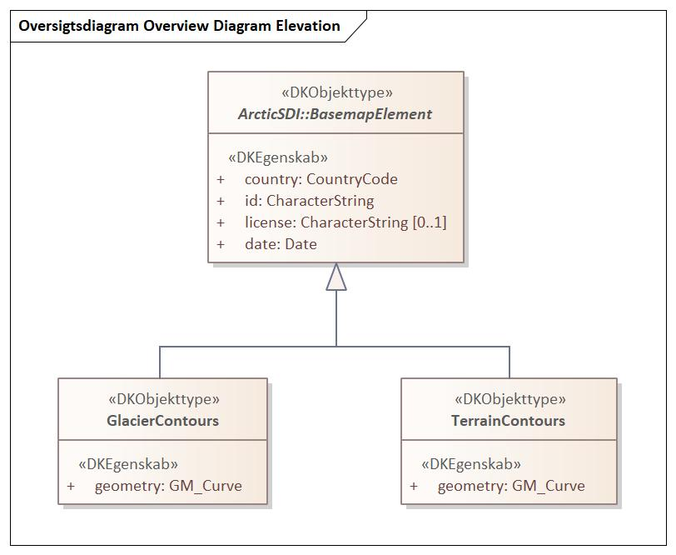

Figure - Overview Diagram Elevation

### GlacierContours

|  |  |  |  |  |
| --- | --- | --- | --- | --- |
| **GlacierContours**   |  |  | | --- | --- | | **Subtype of:** | BasemapElement | | **Type:** | Feature type | |
| **Attribute:**   |  |  | | --- | --- | | **Name:** | country | | **Definition:** | three-letter country code defined in ISO 3166-1 | | **Multiplicity:** | 1 | | **Value type:** | CountryCode (code list) | |
| **Attribute:**   |  |  | | --- | --- | | **Name:** | id | | **Definition:** | identifikation of the feature which in combination with the country code is unique | | **Multiplicity:** | 1 | | **Value type:** | CharacterString | |
| **Attribute:**   |  |  | | --- | --- | | **Name:** | license | | **Definition:** | description or reference to any commercial (or similar) license or copyright notice applicable to information regarding the feature or data set | | **Multiplicity:** | 0..1 | | **Value type:** | CharacterString | |
| **Attribute:**   |  |  | | --- | --- | | **Name:** | date | | **Definition:** | date supplied in the data delivery | | **Description:** | The date may come from the source data or it may be set when extracting and transferring data, i.e. the organization supplying the data decides how the atribute is populated. | | **Multiplicity:** | 1 | | **Value type:** | Date | |
| **Attribute:**   |  |  | | --- | --- | | **Name:** | geometry | | **Multiplicity:** | 1 | | **Value type:** | GM_Curve | |

### TerrainContours

|  |  |  |  |  |
| --- | --- | --- | --- | --- |
| **TerrainContours**   |  |  | | --- | --- | | **Subtype of:** | BasemapElement | | **Type:** | Feature type | |
| **Attribute:**   |  |  | | --- | --- | | **Name:** | country | | **Definition:** | three-letter country code defined in ISO 3166-1 | | **Multiplicity:** | 1 | | **Value type:** | CountryCode (code list) | |
| **Attribute:**   |  |  | | --- | --- | | **Name:** | id | | **Definition:** | identifikation of the feature which in combination with the country code is unique | | **Multiplicity:** | 1 | | **Value type:** | CharacterString | |
| **Attribute:**   |  |  | | --- | --- | | **Name:** | license | | **Definition:** | description or reference to any commercial (or similar) license or copyright notice applicable to information regarding the feature or data set | | **Multiplicity:** | 0..1 | | **Value type:** | CharacterString | |
| **Attribute:**   |  |  | | --- | --- | | **Name:** | date | | **Definition:** | date supplied in the data delivery | | **Description:** | The date may come from the source data or it may be set when extracting and transferring data, i.e. the organization supplying the data decides how the atribute is populated. | | **Multiplicity:** | 1 | | **Value type:** | Date | |
| **Attribute:**   |  |  | | --- | --- | | **Name:** | geometry | | **Multiplicity:** | 1 | | **Value type:** | GM_Curve | |

## Package: Hydrography

**Parent package:**

ArcticSDI

**Diagram(s):**

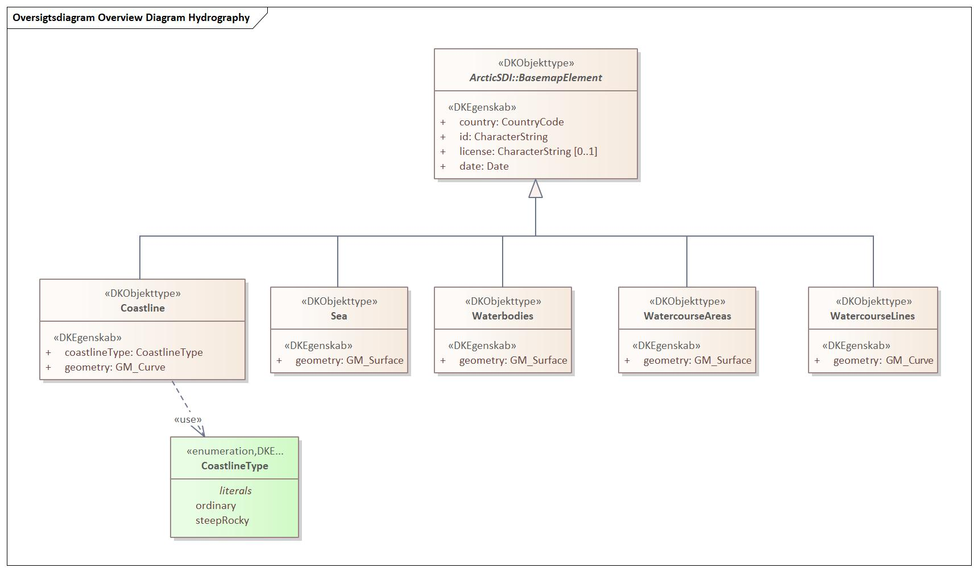

Figure - Overview Diagram Hydrography

### Coastline

|  |  |  |  |  |
| --- | --- | --- | --- | --- |
| **Coastline**   |  |  | | --- | --- | | **Subtype of:** | BasemapElement | | **Type:** | Feature type | |
| **Attribute:**   |  |  | | --- | --- | | **Name:** | country | | **Definition:** | three-letter country code defined in ISO 3166-1 | | **Multiplicity:** | 1 | | **Value type:** | CountryCode (code list) | |
| **Attribute:**   |  |  | | --- | --- | | **Name:** | id | | **Definition:** | identifikation of the feature which in combination with the country code is unique | | **Multiplicity:** | 1 | | **Value type:** | CharacterString | |
| **Attribute:**   |  |  | | --- | --- | | **Name:** | license | | **Definition:** | description or reference to any commercial (or similar) license or copyright notice applicable to information regarding the feature or data set | | **Multiplicity:** | 0..1 | | **Value type:** | CharacterString | |
| **Attribute:**   |  |  | | --- | --- | | **Name:** | date | | **Definition:** | date supplied in the data delivery | | **Description:** | The date may come from the source data or it may be set when extracting and transferring data, i.e. the organization supplying the data decides how the atribute is populated. | | **Multiplicity:** | 1 | | **Value type:** | Date | |
| **Attribute:**   |  |  | | --- | --- | | **Name:** | coastlineType | | **Multiplicity:** | 1 | | **Value type:** | CoastlineType (enumeration) | | **Values** | |  |  | | --- | --- | | ordinary |  | | steepRocky |  | | |
| **Attribute:**   |  |  | | --- | --- | | **Name:** | geometry | | **Multiplicity:** | 1 | | **Value type:** | GM_Curve | |

### Sea

|  |  |  |  |  |
| --- | --- | --- | --- | --- |
| **Sea**   |  |  | | --- | --- | | **Subtype of:** | BasemapElement | | **Type:** | Feature type | |
| **Attribute:**   |  |  | | --- | --- | | **Name:** | country | | **Definition:** | three-letter country code defined in ISO 3166-1 | | **Multiplicity:** | 1 | | **Value type:** | CountryCode (code list) | |
| **Attribute:**   |  |  | | --- | --- | | **Name:** | id | | **Definition:** | identifikation of the feature which in combination with the country code is unique | | **Multiplicity:** | 1 | | **Value type:** | CharacterString | |
| **Attribute:**   |  |  | | --- | --- | | **Name:** | license | | **Definition:** | description or reference to any commercial (or similar) license or copyright notice applicable to information regarding the feature or data set | | **Multiplicity:** | 0..1 | | **Value type:** | CharacterString | |
| **Attribute:**   |  |  | | --- | --- | | **Name:** | date | | **Definition:** | date supplied in the data delivery | | **Description:** | The date may come from the source data or it may be set when extracting and transferring data, i.e. the organization supplying the data decides how the atribute is populated. | | **Multiplicity:** | 1 | | **Value type:** | Date | |
| **Attribute:**   |  |  | | --- | --- | | **Name:** | geometry | | **Multiplicity:** | 1 | | **Value type:** | GM_Surface | |

### Waterbodies

|  |  |  |  |  |
| --- | --- | --- | --- | --- |
| **Waterbodies**   |  |  | | --- | --- | | **Subtype of:** | BasemapElement | | **Type:** | Feature type | |
| **Attribute:**   |  |  | | --- | --- | | **Name:** | country | | **Definition:** | three-letter country code defined in ISO 3166-1 | | **Multiplicity:** | 1 | | **Value type:** | CountryCode (code list) | |
| **Attribute:**   |  |  | | --- | --- | | **Name:** | id | | **Definition:** | identifikation of the feature which in combination with the country code is unique | | **Multiplicity:** | 1 | | **Value type:** | CharacterString | |
| **Attribute:**   |  |  | | --- | --- | | **Name:** | license | | **Definition:** | description or reference to any commercial (or similar) license or copyright notice applicable to information regarding the feature or data set | | **Multiplicity:** | 0..1 | | **Value type:** | CharacterString | |
| **Attribute:**   |  |  | | --- | --- | | **Name:** | date | | **Definition:** | date supplied in the data delivery | | **Description:** | The date may come from the source data or it may be set when extracting and transferring data, i.e. the organization supplying the data decides how the atribute is populated. | | **Multiplicity:** | 1 | | **Value type:** | Date | |
| **Attribute:**   |  |  | | --- | --- | | **Name:** | geometry | | **Multiplicity:** | 1 | | **Value type:** | GM_Surface | |

### WatercourseAreas

|  |  |  |  |  |
| --- | --- | --- | --- | --- |
| **WatercourseAreas**   |  |  | | --- | --- | | **Subtype of:** | BasemapElement | | **Type:** | Feature type | |
| **Attribute:**   |  |  | | --- | --- | | **Name:** | country | | **Definition:** | three-letter country code defined in ISO 3166-1 | | **Multiplicity:** | 1 | | **Value type:** | CountryCode (code list) | |
| **Attribute:**   |  |  | | --- | --- | | **Name:** | id | | **Definition:** | identifikation of the feature which in combination with the country code is unique | | **Multiplicity:** | 1 | | **Value type:** | CharacterString | |
| **Attribute:**   |  |  | | --- | --- | | **Name:** | license | | **Definition:** | description or reference to any commercial (or similar) license or copyright notice applicable to information regarding the feature or data set | | **Multiplicity:** | 0..1 | | **Value type:** | CharacterString | |
| **Attribute:**   |  |  | | --- | --- | | **Name:** | date | | **Definition:** | date supplied in the data delivery | | **Description:** | The date may come from the source data or it may be set when extracting and transferring data, i.e. the organization supplying the data decides how the atribute is populated. | | **Multiplicity:** | 1 | | **Value type:** | Date | |
| **Attribute:**   |  |  | | --- | --- | | **Name:** | geometry | | **Multiplicity:** | 1 | | **Value type:** | GM_Surface | |

### WatercourseLines

|  |  |  |  |  |
| --- | --- | --- | --- | --- |
| **WatercourseLines**   |  |  | | --- | --- | | **Subtype of:** | BasemapElement | | **Type:** | Feature type | |
| **Attribute:**   |  |  | | --- | --- | | **Name:** | country | | **Definition:** | three-letter country code defined in ISO 3166-1 | | **Multiplicity:** | 1 | | **Value type:** | CountryCode (code list) | |
| **Attribute:**   |  |  | | --- | --- | | **Name:** | id | | **Definition:** | identifikation of the feature which in combination with the country code is unique | | **Multiplicity:** | 1 | | **Value type:** | CharacterString | |
| **Attribute:**   |  |  | | --- | --- | | **Name:** | license | | **Definition:** | description or reference to any commercial (or similar) license or copyright notice applicable to information regarding the feature or data set | | **Multiplicity:** | 0..1 | | **Value type:** | CharacterString | |
| **Attribute:**   |  |  | | --- | --- | | **Name:** | date | | **Definition:** | date supplied in the data delivery | | **Description:** | The date may come from the source data or it may be set when extracting and transferring data, i.e. the organization supplying the data decides how the atribute is populated. | | **Multiplicity:** | 1 | | **Value type:** | Date | |
| **Attribute:**   |  |  | | --- | --- | | **Name:** | geometry | | **Multiplicity:** | 1 | | **Value type:** | GM_Curve | |

## Package: LandCover

**Parent package:**

ArcticSDI

**Diagram(s):**

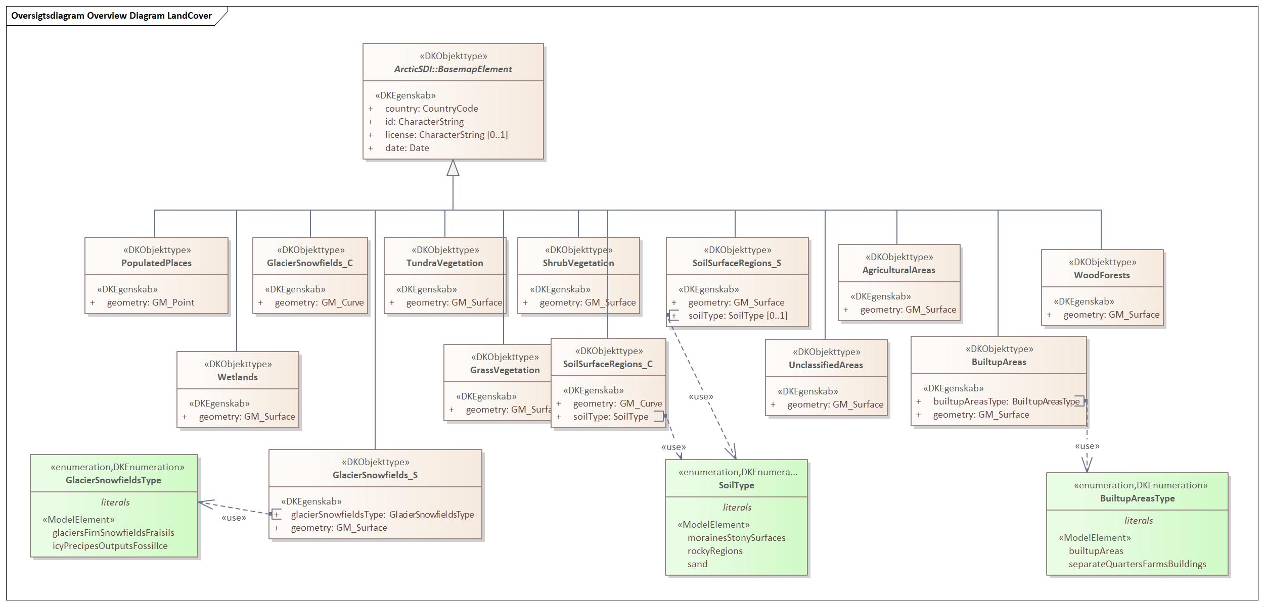

Figure - Overview Diagram LandCover

### AgriculturalAreas

|  |  |  |  |  |
| --- | --- | --- | --- | --- |
| **AgriculturalAreas**   |  |  | | --- | --- | | **Subtype of:** | BasemapElement | | **Type:** | Feature type | |
| **Attribute:**   |  |  | | --- | --- | | **Name:** | country | | **Definition:** | three-letter country code defined in ISO 3166-1 | | **Multiplicity:** | 1 | | **Value type:** | CountryCode (code list) | |
| **Attribute:**   |  |  | | --- | --- | | **Name:** | id | | **Definition:** | identifikation of the feature which in combination with the country code is unique | | **Multiplicity:** | 1 | | **Value type:** | CharacterString | |
| **Attribute:**   |  |  | | --- | --- | | **Name:** | license | | **Definition:** | description or reference to any commercial (or similar) license or copyright notice applicable to information regarding the feature or data set | | **Multiplicity:** | 0..1 | | **Value type:** | CharacterString | |
| **Attribute:**   |  |  | | --- | --- | | **Name:** | date | | **Definition:** | date supplied in the data delivery | | **Description:** | The date may come from the source data or it may be set when extracting and transferring data, i.e. the organization supplying the data decides how the atribute is populated. | | **Multiplicity:** | 1 | | **Value type:** | Date | |
| **Attribute:**   |  |  | | --- | --- | | **Name:** | geometry | | **Multiplicity:** | 1 | | **Value type:** | GM_Surface | |

### BuiltupAreas

|  |  |  |  |  |
| --- | --- | --- | --- | --- |
| **BuiltupAreas**   |  |  | | --- | --- | | **Subtype of:** | BasemapElement | | **Type:** | Feature type | |
| **Attribute:**   |  |  | | --- | --- | | **Name:** | country | | **Definition:** | three-letter country code defined in ISO 3166-1 | | **Multiplicity:** | 1 | | **Value type:** | CountryCode (code list) | |
| **Attribute:**   |  |  | | --- | --- | | **Name:** | id | | **Definition:** | identifikation of the feature which in combination with the country code is unique | | **Multiplicity:** | 1 | | **Value type:** | CharacterString | |
| **Attribute:**   |  |  | | --- | --- | | **Name:** | license | | **Definition:** | description or reference to any commercial (or similar) license or copyright notice applicable to information regarding the feature or data set | | **Multiplicity:** | 0..1 | | **Value type:** | CharacterString | |
| **Attribute:**   |  |  | | --- | --- | | **Name:** | date | | **Definition:** | date supplied in the data delivery | | **Description:** | The date may come from the source data or it may be set when extracting and transferring data, i.e. the organization supplying the data decides how the atribute is populated. | | **Multiplicity:** | 1 | | **Value type:** | Date | |
| **Attribute:**   |  |  | | --- | --- | | **Name:** | builtupAreasType | | **Multiplicity:** | 1 | | **Value type:** | BuiltupAreasType (enumeration) | | **Values** | |  |  | | --- | --- | | builtupAreas |  | | separateQuartersFarmsBuildings |  | | |
| **Attribute:**   |  |  | | --- | --- | | **Name:** | geometry | | **Multiplicity:** | 1 | | **Value type:** | GM_Surface | |

### GlacierSnowfields_C

|  |  |  |  |  |
| --- | --- | --- | --- | --- |
| **GlacierSnowfields_C**   |  |  | | --- | --- | | **Subtype of:** | BasemapElement | | **Type:** | Feature type | |
| **Attribute:**   |  |  | | --- | --- | | **Name:** | country | | **Definition:** | three-letter country code defined in ISO 3166-1 | | **Multiplicity:** | 1 | | **Value type:** | CountryCode (code list) | |
| **Attribute:**   |  |  | | --- | --- | | **Name:** | id | | **Definition:** | identifikation of the feature which in combination with the country code is unique | | **Multiplicity:** | 1 | | **Value type:** | CharacterString | |
| **Attribute:**   |  |  | | --- | --- | | **Name:** | license | | **Definition:** | description or reference to any commercial (or similar) license or copyright notice applicable to information regarding the feature or data set | | **Multiplicity:** | 0..1 | | **Value type:** | CharacterString | |
| **Attribute:**   |  |  | | --- | --- | | **Name:** | date | | **Definition:** | date supplied in the data delivery | | **Description:** | The date may come from the source data or it may be set when extracting and transferring data, i.e. the organization supplying the data decides how the atribute is populated. | | **Multiplicity:** | 1 | | **Value type:** | Date | |
| **Attribute:**   |  |  | | --- | --- | | **Name:** | geometry | | **Multiplicity:** | 1 | | **Value type:** | GM_Curve | |

### GlacierSnowfields_S

|  |  |  |  |  |
| --- | --- | --- | --- | --- |
| **GlacierSnowfields_S**   |  |  | | --- | --- | | **Subtype of:** | BasemapElement | | **Type:** | Feature type | |
| **Attribute:**   |  |  | | --- | --- | | **Name:** | country | | **Definition:** | three-letter country code defined in ISO 3166-1 | | **Multiplicity:** | 1 | | **Value type:** | CountryCode (code list) | |
| **Attribute:**   |  |  | | --- | --- | | **Name:** | id | | **Definition:** | identifikation of the feature which in combination with the country code is unique | | **Multiplicity:** | 1 | | **Value type:** | CharacterString | |
| **Attribute:**   |  |  | | --- | --- | | **Name:** | license | | **Definition:** | description or reference to any commercial (or similar) license or copyright notice applicable to information regarding the feature or data set | | **Multiplicity:** | 0..1 | | **Value type:** | CharacterString | |
| **Attribute:**   |  |  | | --- | --- | | **Name:** | date | | **Definition:** | date supplied in the data delivery | | **Description:** | The date may come from the source data or it may be set when extracting and transferring data, i.e. the organization supplying the data decides how the atribute is populated. | | **Multiplicity:** | 1 | | **Value type:** | Date | |
| **Attribute:**   |  |  | | --- | --- | | **Name:** | glacierSnowfieldsType | | **Multiplicity:** | 1 | | **Value type:** | GlacierSnowfieldsType (enumeration) | | **Values** | |  |  | | --- | --- | | glaciersFirnSnowfieldsFraisils |  | | icyPrecipesOutputsFossilIce |  | | |
| **Attribute:**   |  |  | | --- | --- | | **Name:** | geometry | | **Multiplicity:** | 1 | | **Value type:** | GM_Surface | |

### GrassVegetation

|  |  |  |  |  |
| --- | --- | --- | --- | --- |
| **GrassVegetation**   |  |  | | --- | --- | | **Subtype of:** | BasemapElement | | **Type:** | Feature type | |
| **Attribute:**   |  |  | | --- | --- | | **Name:** | country | | **Definition:** | three-letter country code defined in ISO 3166-1 | | **Multiplicity:** | 1 | | **Value type:** | CountryCode (code list) | |
| **Attribute:**   |  |  | | --- | --- | | **Name:** | id | | **Definition:** | identifikation of the feature which in combination with the country code is unique | | **Multiplicity:** | 1 | | **Value type:** | CharacterString | |
| **Attribute:**   |  |  | | --- | --- | | **Name:** | license | | **Definition:** | description or reference to any commercial (or similar) license or copyright notice applicable to information regarding the feature or data set | | **Multiplicity:** | 0..1 | | **Value type:** | CharacterString | |
| **Attribute:**   |  |  | | --- | --- | | **Name:** | date | | **Definition:** | date supplied in the data delivery | | **Description:** | The date may come from the source data or it may be set when extracting and transferring data, i.e. the organization supplying the data decides how the atribute is populated. | | **Multiplicity:** | 1 | | **Value type:** | Date | |
| **Attribute:**   |  |  | | --- | --- | | **Name:** | geometry | | **Multiplicity:** | 1 | | **Value type:** | GM_Surface | |

### PopulatedPlaces

|  |  |  |  |  |
| --- | --- | --- | --- | --- |
| **PopulatedPlaces**   |  |  | | --- | --- | | **Subtype of:** | BasemapElement | | **Type:** | Feature type | |
| **Attribute:**   |  |  | | --- | --- | | **Name:** | country | | **Definition:** | three-letter country code defined in ISO 3166-1 | | **Multiplicity:** | 1 | | **Value type:** | CountryCode (code list) | |
| **Attribute:**   |  |  | | --- | --- | | **Name:** | id | | **Definition:** | identifikation of the feature which in combination with the country code is unique | | **Multiplicity:** | 1 | | **Value type:** | CharacterString | |
| **Attribute:**   |  |  | | --- | --- | | **Name:** | license | | **Definition:** | description or reference to any commercial (or similar) license or copyright notice applicable to information regarding the feature or data set | | **Multiplicity:** | 0..1 | | **Value type:** | CharacterString | |
| **Attribute:**   |  |  | | --- | --- | | **Name:** | date | | **Definition:** | date supplied in the data delivery | | **Description:** | The date may come from the source data or it may be set when extracting and transferring data, i.e. the organization supplying the data decides how the atribute is populated. | | **Multiplicity:** | 1 | | **Value type:** | Date | |
| **Attribute:**   |  |  | | --- | --- | | **Name:** | geometry | | **Multiplicity:** | 1 | | **Value type:** | GM_Point | |

### ShrubVegetation

|  |  |  |  |  |
| --- | --- | --- | --- | --- |
| **ShrubVegetation**   |  |  | | --- | --- | | **Subtype of:** | BasemapElement | | **Type:** | Feature type | |
| **Attribute:**   |  |  | | --- | --- | | **Name:** | country | | **Definition:** | three-letter country code defined in ISO 3166-1 | | **Multiplicity:** | 1 | | **Value type:** | CountryCode (code list) | |
| **Attribute:**   |  |  | | --- | --- | | **Name:** | id | | **Definition:** | identifikation of the feature which in combination with the country code is unique | | **Multiplicity:** | 1 | | **Value type:** | CharacterString | |
| **Attribute:**   |  |  | | --- | --- | | **Name:** | license | | **Definition:** | description or reference to any commercial (or similar) license or copyright notice applicable to information regarding the feature or data set | | **Multiplicity:** | 0..1 | | **Value type:** | CharacterString | |
| **Attribute:**   |  |  | | --- | --- | | **Name:** | date | | **Definition:** | date supplied in the data delivery | | **Description:** | The date may come from the source data or it may be set when extracting and transferring data, i.e. the organization supplying the data decides how the atribute is populated. | | **Multiplicity:** | 1 | | **Value type:** | Date | |
| **Attribute:**   |  |  | | --- | --- | | **Name:** | geometry | | **Multiplicity:** | 1 | | **Value type:** | GM_Surface | |

### SoilSurfaceRegions_C

|  |  |  |  |  |
| --- | --- | --- | --- | --- |
| **SoilSurfaceRegions_C**   |  |  | | --- | --- | | **Subtype of:** | BasemapElement | | **Type:** | Feature type | |
| **Attribute:**   |  |  | | --- | --- | | **Name:** | country | | **Definition:** | three-letter country code defined in ISO 3166-1 | | **Multiplicity:** | 1 | | **Value type:** | CountryCode (code list) | |
| **Attribute:**   |  |  | | --- | --- | | **Name:** | id | | **Definition:** | identifikation of the feature which in combination with the country code is unique | | **Multiplicity:** | 1 | | **Value type:** | CharacterString | |
| **Attribute:**   |  |  | | --- | --- | | **Name:** | license | | **Definition:** | description or reference to any commercial (or similar) license or copyright notice applicable to information regarding the feature or data set | | **Multiplicity:** | 0..1 | | **Value type:** | CharacterString | |
| **Attribute:**   |  |  | | --- | --- | | **Name:** | date | | **Definition:** | date supplied in the data delivery | | **Description:** | The date may come from the source data or it may be set when extracting and transferring data, i.e. the organization supplying the data decides how the atribute is populated. | | **Multiplicity:** | 1 | | **Value type:** | Date | |
| **Attribute:**   |  |  | | --- | --- | | **Name:** | geometry | | **Multiplicity:** | 1 | | **Value type:** | GM_Curve | |
| **Attribute:**   |  |  | | --- | --- | | **Name:** | soilType | | **Multiplicity:** | 1 | | **Value type:** | SoilType (enumeration) | | **Values** | |  |  | | --- | --- | | morainesStonySurfaces |  | | rockyRegions |  | | sand |  | | |

### SoilSurfaceRegions_S

|  |  |  |  |  |
| --- | --- | --- | --- | --- |
| **SoilSurfaceRegions_S**   |  |  | | --- | --- | | **Subtype of:** | BasemapElement | | **Type:** | Feature type | |
| **Attribute:**   |  |  | | --- | --- | | **Name:** | country | | **Definition:** | three-letter country code defined in ISO 3166-1 | | **Multiplicity:** | 1 | | **Value type:** | CountryCode (code list) | |
| **Attribute:**   |  |  | | --- | --- | | **Name:** | id | | **Definition:** | identifikation of the feature which in combination with the country code is unique | | **Multiplicity:** | 1 | | **Value type:** | CharacterString | |
| **Attribute:**   |  |  | | --- | --- | | **Name:** | license | | **Definition:** | description or reference to any commercial (or similar) license or copyright notice applicable to information regarding the feature or data set | | **Multiplicity:** | 0..1 | | **Value type:** | CharacterString | |
| **Attribute:**   |  |  | | --- | --- | | **Name:** | date | | **Definition:** | date supplied in the data delivery | | **Description:** | The date may come from the source data or it may be set when extracting and transferring data, i.e. the organization supplying the data decides how the atribute is populated. | | **Multiplicity:** | 1 | | **Value type:** | Date | |
| **Attribute:**   |  |  | | --- | --- | | **Name:** | geometry | | **Multiplicity:** | 1 | | **Value type:** | GM_Surface | |
| **Attribute:**   |  |  | | --- | --- | | **Name:** | soilType | | **Multiplicity:** | 0..1 | | **Value type:** | SoilType (enumeration) | | **Values** | |  |  | | --- | --- | | morainesStonySurfaces |  | | rockyRegions |  | | sand |  | | |

### TundraVegetation

|  |  |  |  |  |
| --- | --- | --- | --- | --- |
| **TundraVegetation**   |  |  | | --- | --- | | **Subtype of:** | BasemapElement | | **Type:** | Feature type | |
| **Attribute:**   |  |  | | --- | --- | | **Name:** | country | | **Definition:** | three-letter country code defined in ISO 3166-1 | | **Multiplicity:** | 1 | | **Value type:** | CountryCode (code list) | |
| **Attribute:**   |  |  | | --- | --- | | **Name:** | id | | **Definition:** | identifikation of the feature which in combination with the country code is unique | | **Multiplicity:** | 1 | | **Value type:** | CharacterString | |
| **Attribute:**   |  |  | | --- | --- | | **Name:** | license | | **Definition:** | description or reference to any commercial (or similar) license or copyright notice applicable to information regarding the feature or data set | | **Multiplicity:** | 0..1 | | **Value type:** | CharacterString | |
| **Attribute:**   |  |  | | --- | --- | | **Name:** | date | | **Definition:** | date supplied in the data delivery | | **Description:** | The date may come from the source data or it may be set when extracting and transferring data, i.e. the organization supplying the data decides how the atribute is populated. | | **Multiplicity:** | 1 | | **Value type:** | Date | |
| **Attribute:**   |  |  | | --- | --- | | **Name:** | geometry | | **Multiplicity:** | 1 | | **Value type:** | GM_Surface | |

### UnclassifiedAreas

|  |  |  |  |  |
| --- | --- | --- | --- | --- |
| **UnclassifiedAreas**   |  |  | | --- | --- | | **Subtype of:** | BasemapElement | | **Type:** | Feature type | |
| **Attribute:**   |  |  | | --- | --- | | **Name:** | country | | **Definition:** | three-letter country code defined in ISO 3166-1 | | **Multiplicity:** | 1 | | **Value type:** | CountryCode (code list) | |
| **Attribute:**   |  |  | | --- | --- | | **Name:** | id | | **Definition:** | identifikation of the feature which in combination with the country code is unique | | **Multiplicity:** | 1 | | **Value type:** | CharacterString | |
| **Attribute:**   |  |  | | --- | --- | | **Name:** | license | | **Definition:** | description or reference to any commercial (or similar) license or copyright notice applicable to information regarding the feature or data set | | **Multiplicity:** | 0..1 | | **Value type:** | CharacterString | |
| **Attribute:**   |  |  | | --- | --- | | **Name:** | date | | **Definition:** | date supplied in the data delivery | | **Description:** | The date may come from the source data or it may be set when extracting and transferring data, i.e. the organization supplying the data decides how the atribute is populated. | | **Multiplicity:** | 1 | | **Value type:** | Date | |
| **Attribute:**   |  |  | | --- | --- | | **Name:** | geometry | | **Multiplicity:** | 1 | | **Value type:** | GM_Surface | |

### Wetlands

|  |  |  |  |  |
| --- | --- | --- | --- | --- |
| **Wetlands**   |  |  | | --- | --- | | **Subtype of:** | BasemapElement | | **Type:** | Feature type | |
| **Attribute:**   |  |  | | --- | --- | | **Name:** | country | | **Definition:** | three-letter country code defined in ISO 3166-1 | | **Multiplicity:** | 1 | | **Value type:** | CountryCode (code list) | |
| **Attribute:**   |  |  | | --- | --- | | **Name:** | id | | **Definition:** | identifikation of the feature which in combination with the country code is unique | | **Multiplicity:** | 1 | | **Value type:** | CharacterString | |
| **Attribute:**   |  |  | | --- | --- | | **Name:** | license | | **Definition:** | description or reference to any commercial (or similar) license or copyright notice applicable to information regarding the feature or data set | | **Multiplicity:** | 0..1 | | **Value type:** | CharacterString | |
| **Attribute:**   |  |  | | --- | --- | | **Name:** | date | | **Definition:** | date supplied in the data delivery | | **Description:** | The date may come from the source data or it may be set when extracting and transferring data, i.e. the organization supplying the data decides how the atribute is populated. | | **Multiplicity:** | 1 | | **Value type:** | Date | |
| **Attribute:**   |  |  | | --- | --- | | **Name:** | geometry | | **Multiplicity:** | 1 | | **Value type:** | GM_Surface | |

### WoodForests

|  |  |  |  |  |
| --- | --- | --- | --- | --- |
| **WoodForests**   |  |  | | --- | --- | | **Subtype of:** | BasemapElement | | **Type:** | Feature type | |
| **Attribute:**   |  |  | | --- | --- | | **Name:** | country | | **Definition:** | three-letter country code defined in ISO 3166-1 | | **Multiplicity:** | 1 | | **Value type:** | CountryCode (code list) | |
| **Attribute:**   |  |  | | --- | --- | | **Name:** | id | | **Definition:** | identifikation of the feature which in combination with the country code is unique | | **Multiplicity:** | 1 | | **Value type:** | CharacterString | |
| **Attribute:**   |  |  | | --- | --- | | **Name:** | license | | **Definition:** | description or reference to any commercial (or similar) license or copyright notice applicable to information regarding the feature or data set | | **Multiplicity:** | 0..1 | | **Value type:** | CharacterString | |
| **Attribute:**   |  |  | | --- | --- | | **Name:** | date | | **Definition:** | date supplied in the data delivery | | **Description:** | The date may come from the source data or it may be set when extracting and transferring data, i.e. the organization supplying the data decides how the atribute is populated. | | **Multiplicity:** | 1 | | **Value type:** | Date | |
| **Attribute:**   |  |  | | --- | --- | | **Name:** | geometry | | **Multiplicity:** | 1 | | **Value type:** | GM_Surface | |

## Package: TransportNetworks

**Parent package:**

ArcticSDI

**Diagram(s):**

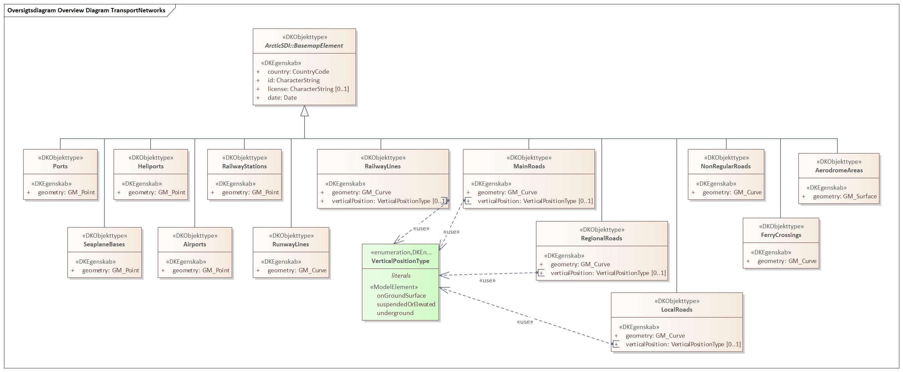

Figure - Overview Diagram TransportNetworks

### AerodromeAreas

|  |  |  |  |  |
| --- | --- | --- | --- | --- |
| **AerodromeAreas**   |  |  | | --- | --- | | **Subtype of:** | BasemapElement | | **Type:** | Feature type | |
| **Attribute:**   |  |  | | --- | --- | | **Name:** | country | | **Definition:** | three-letter country code defined in ISO 3166-1 | | **Multiplicity:** | 1 | | **Value type:** | CountryCode (code list) | |
| **Attribute:**   |  |  | | --- | --- | | **Name:** | id | | **Definition:** | identifikation of the feature which in combination with the country code is unique | | **Multiplicity:** | 1 | | **Value type:** | CharacterString | |
| **Attribute:**   |  |  | | --- | --- | | **Name:** | license | | **Definition:** | description or reference to any commercial (or similar) license or copyright notice applicable to information regarding the feature or data set | | **Multiplicity:** | 0..1 | | **Value type:** | CharacterString | |
| **Attribute:**   |  |  | | --- | --- | | **Name:** | date | | **Definition:** | date supplied in the data delivery | | **Description:** | The date may come from the source data or it may be set when extracting and transferring data, i.e. the organization supplying the data decides how the atribute is populated. | | **Multiplicity:** | 1 | | **Value type:** | Date | |
| **Attribute:**   |  |  | | --- | --- | | **Name:** | geometry | | **Multiplicity:** | 1 | | **Value type:** | GM_Surface | |

### Airports

|  |  |  |  |  |
| --- | --- | --- | --- | --- |
| **Airports**   |  |  | | --- | --- | | **Subtype of:** | BasemapElement | | **Type:** | Feature type | |
| **Attribute:**   |  |  | | --- | --- | | **Name:** | country | | **Definition:** | three-letter country code defined in ISO 3166-1 | | **Multiplicity:** | 1 | | **Value type:** | CountryCode (code list) | |
| **Attribute:**   |  |  | | --- | --- | | **Name:** | id | | **Definition:** | identifikation of the feature which in combination with the country code is unique | | **Multiplicity:** | 1 | | **Value type:** | CharacterString | |
| **Attribute:**   |  |  | | --- | --- | | **Name:** | license | | **Definition:** | description or reference to any commercial (or similar) license or copyright notice applicable to information regarding the feature or data set | | **Multiplicity:** | 0..1 | | **Value type:** | CharacterString | |
| **Attribute:**   |  |  | | --- | --- | | **Name:** | date | | **Definition:** | date supplied in the data delivery | | **Description:** | The date may come from the source data or it may be set when extracting and transferring data, i.e. the organization supplying the data decides how the atribute is populated. | | **Multiplicity:** | 1 | | **Value type:** | Date | |
| **Attribute:**   |  |  | | --- | --- | | **Name:** | geometry | | **Multiplicity:** | 1 | | **Value type:** | GM_Point | |

### FerryCrossings

|  |  |  |  |  |
| --- | --- | --- | --- | --- |
| **FerryCrossings**   |  |  | | --- | --- | | **Subtype of:** | BasemapElement | | **Type:** | Feature type | |
| **Attribute:**   |  |  | | --- | --- | | **Name:** | country | | **Definition:** | three-letter country code defined in ISO 3166-1 | | **Multiplicity:** | 1 | | **Value type:** | CountryCode (code list) | |
| **Attribute:**   |  |  | | --- | --- | | **Name:** | id | | **Definition:** | identifikation of the feature which in combination with the country code is unique | | **Multiplicity:** | 1 | | **Value type:** | CharacterString | |
| **Attribute:**   |  |  | | --- | --- | | **Name:** | license | | **Definition:** | description or reference to any commercial (or similar) license or copyright notice applicable to information regarding the feature or data set | | **Multiplicity:** | 0..1 | | **Value type:** | CharacterString | |
| **Attribute:**   |  |  | | --- | --- | | **Name:** | date | | **Definition:** | date supplied in the data delivery | | **Description:** | The date may come from the source data or it may be set when extracting and transferring data, i.e. the organization supplying the data decides how the atribute is populated. | | **Multiplicity:** | 1 | | **Value type:** | Date | |
| **Attribute:**   |  |  | | --- | --- | | **Name:** | geometry | | **Multiplicity:** | 1 | | **Value type:** | GM_Curve | |

### Heliports

|  |  |  |  |  |
| --- | --- | --- | --- | --- |
| **Heliports**   |  |  | | --- | --- | | **Subtype of:** | BasemapElement | | **Type:** | Feature type | |
| **Attribute:**   |  |  | | --- | --- | | **Name:** | country | | **Definition:** | three-letter country code defined in ISO 3166-1 | | **Multiplicity:** | 1 | | **Value type:** | CountryCode (code list) | |
| **Attribute:**   |  |  | | --- | --- | | **Name:** | id | | **Definition:** | identifikation of the feature which in combination with the country code is unique | | **Multiplicity:** | 1 | | **Value type:** | CharacterString | |
| **Attribute:**   |  |  | | --- | --- | | **Name:** | license | | **Definition:** | description or reference to any commercial (or similar) license or copyright notice applicable to information regarding the feature or data set | | **Multiplicity:** | 0..1 | | **Value type:** | CharacterString | |
| **Attribute:**   |  |  | | --- | --- | | **Name:** | date | | **Definition:** | date supplied in the data delivery | | **Description:** | The date may come from the source data or it may be set when extracting and transferring data, i.e. the organization supplying the data decides how the atribute is populated. | | **Multiplicity:** | 1 | | **Value type:** | Date | |
| **Attribute:**   |  |  | | --- | --- | | **Name:** | geometry | | **Multiplicity:** | 1 | | **Value type:** | GM_Point | |

### LocalRoads

|  |  |  |  |  |
| --- | --- | --- | --- | --- |
| **LocalRoads**   |  |  | | --- | --- | | **Subtype of:** | BasemapElement | | **Type:** | Feature type | |
| **Attribute:**   |  |  | | --- | --- | | **Name:** | country | | **Definition:** | three-letter country code defined in ISO 3166-1 | | **Multiplicity:** | 1 | | **Value type:** | CountryCode (code list) | |
| **Attribute:**   |  |  | | --- | --- | | **Name:** | id | | **Definition:** | identifikation of the feature which in combination with the country code is unique | | **Multiplicity:** | 1 | | **Value type:** | CharacterString | |
| **Attribute:**   |  |  | | --- | --- | | **Name:** | license | | **Definition:** | description or reference to any commercial (or similar) license or copyright notice applicable to information regarding the feature or data set | | **Multiplicity:** | 0..1 | | **Value type:** | CharacterString | |
| **Attribute:**   |  |  | | --- | --- | | **Name:** | date | | **Definition:** | date supplied in the data delivery | | **Description:** | The date may come from the source data or it may be set when extracting and transferring data, i.e. the organization supplying the data decides how the atribute is populated. | | **Multiplicity:** | 1 | | **Value type:** | Date | |
| **Attribute:**   |  |  | | --- | --- | | **Name:** | geometry | | **Multiplicity:** | 1 | | **Value type:** | GM_Curve | |
| **Attribute:**   |  |  | | --- | --- | | **Name:** | verticalPosition | | **Multiplicity:** | 0..1 | | **Value type:** | VerticalPositionType (enumeration) | | **Values** | |  |  | | --- | --- | | onGroundSurface |  | | suspendedOrElevated |  | | underground |  | | |

### MainRoads

|  |  |  |  |  |
| --- | --- | --- | --- | --- |
| **MainRoads**   |  |  | | --- | --- | | **Subtype of:** | BasemapElement | | **Type:** | Feature type | |
| **Attribute:**   |  |  | | --- | --- | | **Name:** | country | | **Definition:** | three-letter country code defined in ISO 3166-1 | | **Multiplicity:** | 1 | | **Value type:** | CountryCode (code list) | |
| **Attribute:**   |  |  | | --- | --- | | **Name:** | id | | **Definition:** | identifikation of the feature which in combination with the country code is unique | | **Multiplicity:** | 1 | | **Value type:** | CharacterString | |
| **Attribute:**   |  |  | | --- | --- | | **Name:** | license | | **Definition:** | description or reference to any commercial (or similar) license or copyright notice applicable to information regarding the feature or data set | | **Multiplicity:** | 0..1 | | **Value type:** | CharacterString | |
| **Attribute:**   |  |  | | --- | --- | | **Name:** | date | | **Definition:** | date supplied in the data delivery | | **Description:** | The date may come from the source data or it may be set when extracting and transferring data, i.e. the organization supplying the data decides how the atribute is populated. | | **Multiplicity:** | 1 | | **Value type:** | Date | |
| **Attribute:**   |  |  | | --- | --- | | **Name:** | geometry | | **Multiplicity:** | 1 | | **Value type:** | GM_Curve | |
| **Attribute:**   |  |  | | --- | --- | | **Name:** | verticalPosition | | **Multiplicity:** | 0..1 | | **Value type:** | VerticalPositionType (enumeration) | | **Values** | |  |  | | --- | --- | | onGroundSurface |  | | suspendedOrElevated |  | | underground |  | | |

### NonRegularRoads

|  |  |  |  |  |
| --- | --- | --- | --- | --- |
| **NonRegularRoads**   |  |  | | --- | --- | | **Subtype of:** | BasemapElement | | **Type:** | Feature type | |
| **Attribute:**   |  |  | | --- | --- | | **Name:** | country | | **Definition:** | three-letter country code defined in ISO 3166-1 | | **Multiplicity:** | 1 | | **Value type:** | CountryCode (code list) | |
| **Attribute:**   |  |  | | --- | --- | | **Name:** | id | | **Definition:** | identifikation of the feature which in combination with the country code is unique | | **Multiplicity:** | 1 | | **Value type:** | CharacterString | |
| **Attribute:**   |  |  | | --- | --- | | **Name:** | license | | **Definition:** | description or reference to any commercial (or similar) license or copyright notice applicable to information regarding the feature or data set | | **Multiplicity:** | 0..1 | | **Value type:** | CharacterString | |
| **Attribute:**   |  |  | | --- | --- | | **Name:** | date | | **Definition:** | date supplied in the data delivery | | **Description:** | The date may come from the source data or it may be set when extracting and transferring data, i.e. the organization supplying the data decides how the atribute is populated. | | **Multiplicity:** | 1 | | **Value type:** | Date | |
| **Attribute:**   |  |  | | --- | --- | | **Name:** | geometry | | **Multiplicity:** | 1 | | **Value type:** | GM_Curve | |

### Ports

|  |  |  |  |  |
| --- | --- | --- | --- | --- |
| **Ports**   |  |  | | --- | --- | | **Subtype of:** | BasemapElement | | **Type:** | Feature type | |
| **Attribute:**   |  |  | | --- | --- | | **Name:** | country | | **Definition:** | three-letter country code defined in ISO 3166-1 | | **Multiplicity:** | 1 | | **Value type:** | CountryCode (code list) | |
| **Attribute:**   |  |  | | --- | --- | | **Name:** | id | | **Definition:** | identifikation of the feature which in combination with the country code is unique | | **Multiplicity:** | 1 | | **Value type:** | CharacterString | |
| **Attribute:**   |  |  | | --- | --- | | **Name:** | license | | **Definition:** | description or reference to any commercial (or similar) license or copyright notice applicable to information regarding the feature or data set | | **Multiplicity:** | 0..1 | | **Value type:** | CharacterString | |
| **Attribute:**   |  |  | | --- | --- | | **Name:** | date | | **Definition:** | date supplied in the data delivery | | **Description:** | The date may come from the source data or it may be set when extracting and transferring data, i.e. the organization supplying the data decides how the atribute is populated. | | **Multiplicity:** | 1 | | **Value type:** | Date | |
| **Attribute:**   |  |  | | --- | --- | | **Name:** | geometry | | **Multiplicity:** | 1 | | **Value type:** | GM_Point | |

### RailwayLines

|  |  |  |  |  |
| --- | --- | --- | --- | --- |
| **RailwayLines**   |  |  | | --- | --- | | **Subtype of:** | BasemapElement | | **Type:** | Feature type | |
| **Attribute:**   |  |  | | --- | --- | | **Name:** | country | | **Definition:** | three-letter country code defined in ISO 3166-1 | | **Multiplicity:** | 1 | | **Value type:** | CountryCode (code list) | |
| **Attribute:**   |  |  | | --- | --- | | **Name:** | id | | **Definition:** | identifikation of the feature which in combination with the country code is unique | | **Multiplicity:** | 1 | | **Value type:** | CharacterString | |
| **Attribute:**   |  |  | | --- | --- | | **Name:** | license | | **Definition:** | description or reference to any commercial (or similar) license or copyright notice applicable to information regarding the feature or data set | | **Multiplicity:** | 0..1 | | **Value type:** | CharacterString | |
| **Attribute:**   |  |  | | --- | --- | | **Name:** | date | | **Definition:** | date supplied in the data delivery | | **Description:** | The date may come from the source data or it may be set when extracting and transferring data, i.e. the organization supplying the data decides how the atribute is populated. | | **Multiplicity:** | 1 | | **Value type:** | Date | |
| **Attribute:**   |  |  | | --- | --- | | **Name:** | geometry | | **Multiplicity:** | 1 | | **Value type:** | GM_Curve | |
| **Attribute:**   |  |  | | --- | --- | | **Name:** | verticalPosition | | **Multiplicity:** | 0..1 | | **Value type:** | VerticalPositionType (enumeration) | | **Values** | |  |  | | --- | --- | | onGroundSurface |  | | suspendedOrElevated |  | | underground |  | | |

### RailwayStations

|  |  |  |  |  |
| --- | --- | --- | --- | --- |
| **RailwayStations**   |  |  | | --- | --- | | **Subtype of:** | BasemapElement | | **Type:** | Feature type | |
| **Attribute:**   |  |  | | --- | --- | | **Name:** | country | | **Definition:** | three-letter country code defined in ISO 3166-1 | | **Multiplicity:** | 1 | | **Value type:** | CountryCode (code list) | |
| **Attribute:**   |  |  | | --- | --- | | **Name:** | id | | **Definition:** | identifikation of the feature which in combination with the country code is unique | | **Multiplicity:** | 1 | | **Value type:** | CharacterString | |
| **Attribute:**   |  |  | | --- | --- | | **Name:** | license | | **Definition:** | description or reference to any commercial (or similar) license or copyright notice applicable to information regarding the feature or data set | | **Multiplicity:** | 0..1 | | **Value type:** | CharacterString | |
| **Attribute:**   |  |  | | --- | --- | | **Name:** | date | | **Definition:** | date supplied in the data delivery | | **Description:** | The date may come from the source data or it may be set when extracting and transferring data, i.e. the organization supplying the data decides how the atribute is populated. | | **Multiplicity:** | 1 | | **Value type:** | Date | |
| **Attribute:**   |  |  | | --- | --- | | **Name:** | geometry | | **Multiplicity:** | 1 | | **Value type:** | GM_Point | |

### RegionalRoads

|  |  |  |  |  |
| --- | --- | --- | --- | --- |
| **RegionalRoads**   |  |  | | --- | --- | | **Subtype of:** | BasemapElement | | **Type:** | Feature type | |
| **Attribute:**   |  |  | | --- | --- | | **Name:** | country | | **Definition:** | three-letter country code defined in ISO 3166-1 | | **Multiplicity:** | 1 | | **Value type:** | CountryCode (code list) | |
| **Attribute:**   |  |  | | --- | --- | | **Name:** | id | | **Definition:** | identifikation of the feature which in combination with the country code is unique | | **Multiplicity:** | 1 | | **Value type:** | CharacterString | |
| **Attribute:**   |  |  | | --- | --- | | **Name:** | license | | **Definition:** | description or reference to any commercial (or similar) license or copyright notice applicable to information regarding the feature or data set | | **Multiplicity:** | 0..1 | | **Value type:** | CharacterString | |
| **Attribute:**   |  |  | | --- | --- | | **Name:** | date | | **Definition:** | date supplied in the data delivery | | **Description:** | The date may come from the source data or it may be set when extracting and transferring data, i.e. the organization supplying the data decides how the atribute is populated. | | **Multiplicity:** | 1 | | **Value type:** | Date | |
| **Attribute:**   |  |  | | --- | --- | | **Name:** | geometry | | **Multiplicity:** | 1 | | **Value type:** | GM_Curve | |
| **Attribute:**   |  |  | | --- | --- | | **Name:** | verticalPosition | | **Multiplicity:** | 0..1 | | **Value type:** | VerticalPositionType (enumeration) | | **Values** | |  |  | | --- | --- | | onGroundSurface |  | | suspendedOrElevated |  | | underground |  | | |

### RunwayLines

|  |  |  |  |  |
| --- | --- | --- | --- | --- |
| **RunwayLines**   |  |  | | --- | --- | | **Subtype of:** | BasemapElement | | **Type:** | Feature type | |
| **Attribute:**   |  |  | | --- | --- | | **Name:** | country | | **Definition:** | three-letter country code defined in ISO 3166-1 | | **Multiplicity:** | 1 | | **Value type:** | CountryCode (code list) | |
| **Attribute:**   |  |  | | --- | --- | | **Name:** | id | | **Definition:** | identifikation of the feature which in combination with the country code is unique | | **Multiplicity:** | 1 | | **Value type:** | CharacterString | |
| **Attribute:**   |  |  | | --- | --- | | **Name:** | license | | **Definition:** | description or reference to any commercial (or similar) license or copyright notice applicable to information regarding the feature or data set | | **Multiplicity:** | 0..1 | | **Value type:** | CharacterString | |
| **Attribute:**   |  |  | | --- | --- | | **Name:** | date | | **Definition:** | date supplied in the data delivery | | **Description:** | The date may come from the source data or it may be set when extracting and transferring data, i.e. the organization supplying the data decides how the atribute is populated. | | **Multiplicity:** | 1 | | **Value type:** | Date | |
| **Attribute:**   |  |  | | --- | --- | | **Name:** | geometry | | **Multiplicity:** | 1 | | **Value type:** | GM_Curve | |

### SeaplaneBases

|  |  |  |  |  |
| --- | --- | --- | --- | --- |
| **SeaplaneBases**   |  |  | | --- | --- | | **Subtype of:** | BasemapElement | | **Type:** | Feature type | |
| **Attribute:**   |  |  | | --- | --- | | **Name:** | country | | **Definition:** | three-letter country code defined in ISO 3166-1 | | **Multiplicity:** | 1 | | **Value type:** | CountryCode (code list) | |
| **Attribute:**   |  |  | | --- | --- | | **Name:** | id | | **Definition:** | identifikation of the feature which in combination with the country code is unique | | **Multiplicity:** | 1 | | **Value type:** | CharacterString | |
| **Attribute:**   |  |  | | --- | --- | | **Name:** | license | | **Definition:** | description or reference to any commercial (or similar) license or copyright notice applicable to information regarding the feature or data set | | **Multiplicity:** | 0..1 | | **Value type:** | CharacterString | |
| **Attribute:**   |  |  | | --- | --- | | **Name:** | date | | **Definition:** | date supplied in the data delivery | | **Description:** | The date may come from the source data or it may be set when extracting and transferring data, i.e. the organization supplying the data decides how the atribute is populated. | | **Multiplicity:** | 1 | | **Value type:** | Date | |
| **Attribute:**   |  |  | | --- | --- | | **Name:** | geometry | | **Multiplicity:** | 1 | | **Value type:** | GM_Point | |